

**RefWorks log in at USC:**

Go to [www.usc.edu/libraries](http://www.usc.edu/libraries) and click on RefWorks (in the Research Support box at top right of page)

**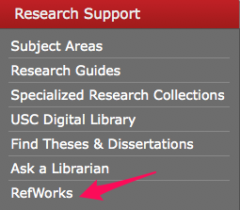**

**Key Features:**

* Automatically creates formatted bibliographies
* Imports RSS feed data
* Has a mobile platform for iPhone use
* Provides access to author/journal info
* Ability to search other catalogs/databases within the interface and import citations

(requires a subscription but USC offers this **free** to students and alumni)

**Using RefWorks** consists of four easy steps (from **libguides.usc.edu/refworks**)

1. [Create an account](https://www.refworks.com/Refworks/newuser.asp) by entering your subscriber information, see: [www.refworks.com/Refworks/newuser.asp](https://www.refworks.com/Refworks/newuser.asp)

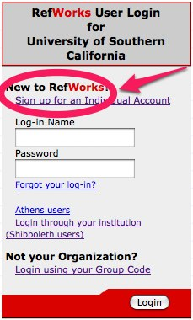

1. Create a database by automatically [importing data from online services](http://libguides.usc.edu/aecontent.php?pid=26786&sid=606794) or by typing references in manually. See instructions at libguides.usc.edu/refworks

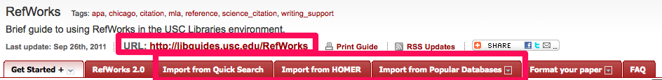

1. Create a paper in your word processor [insert the code for your citation (called a Temporary Citation Placeholder)](http://libguides.usc.edu/aecontent.php?pid=26786&sid=207652) in those locations you want to cite references. Save and close the file.
2. From [RefWorks click on Bibliography](http://libguides.usc.edu/aecontent.php?pid=26786&sid=207652" \t "_blank) and select the paper you just saved and the output style in which you want it created.

Click on Create Bibliography and save the formatted document to disk.

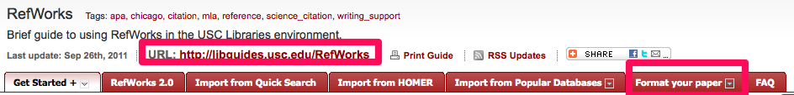

**Accessing RefWorks via Wireless or Off-Campus**

From computers connecting via wireless or off-campus, the USC Group Code is required: **RWUSC**

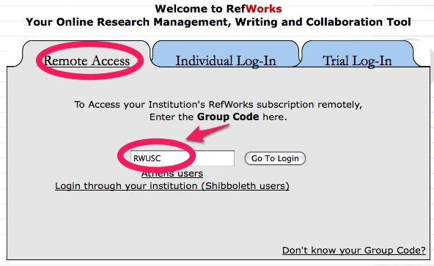

**Getting Help for RefWorks**

**RefWorks at USC Research Guide:** [http://libguides.usc.edu/RefWorks](http://libguides.usc.edu/RefWorks" \t "_blank)

**RefWorks FAQ:** [http://libguides.usc.edu/content.php?pid=26786&sid=207677](http://libguides.usc.edu/content.php?pid=26786&sid=207677" \t "_blank)

For further help, contact the RefWorks support person, John Bonham, [bonham@usc.edu](mailto:bonham@usc.edu).